Climate Issues and Immersive Techniques
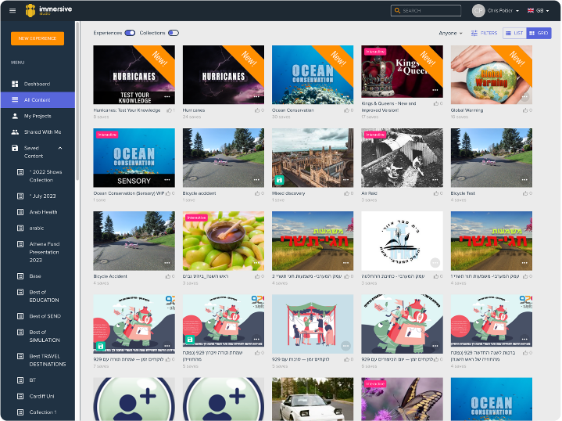
A lot has happened in our planet, rubbish not put in the bin, food wasted and unused, air being polluted with horrid gas and energy being used too much. How can we stop this? Well, we can help educate the youth about its dangers with immersive studios.
With immersive studios, you can create quizzes about what to do when you buy food, the current results of the world’s problems, how to put away your food when you’re done with it, what easily wastes electricity and ways to create renewable energy.
Immersive studios also allow you to create splat games to make educational works more fun than researching if you describe.
For me, I chose the focus to be on food wastage. Not only because there’s so many wastes on the floor, but because I have experience using what to do with the food I eat after I’m full. These choices were preserving them for later usage or feed the food to chickens or birds, depending on if the food is rice, vegetables or bread.

